
PCI-1752U PCI-1752USO

64-ch Sink (NPN) Isolated Digital Output
64-ch Source (PNP) Isolated Digital Output


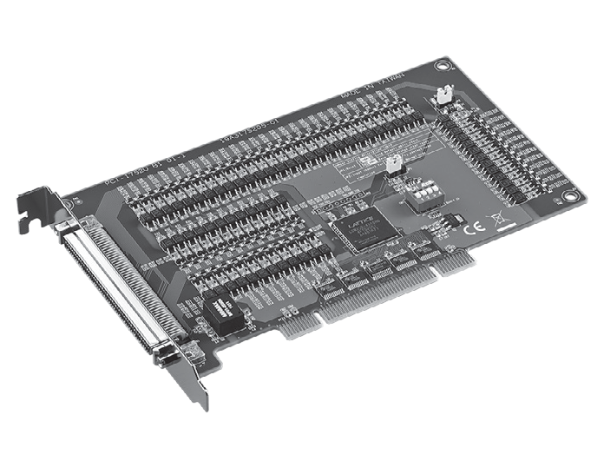

2002/95/EC
RoHS
COMPLIANT
Features
- 64-ch Sink Type (NPN) Isolated Digital Output Module (PCI-1752U Only)
- 64-ch Source Type (PNP) Isolated Digital Output Module (PCI-1752USO Only)
- High-voltage isolation on output channels (2,500 VDC)
- Wide output range (5 ~ 40 VDC)
- High-sink/source current on isolated output channels (200 mA max./channel)
- Output status readback
- Keeps the output settings and values after system hot reset
- Channel-freeze function
- High-density 100-pin SCSI connector
Introduction
The PCI-1752USO is a 64-CH source type isolated digital output which provides a 2,500 V isolation protection. It features a wide output range from 5 to 40V, which makes it suitable for industrial automation applications.

Specifications

Isolated Digital Output
- Channels 64 (16-ch/group)
- Output Type PCI-1752U: Sink (NPN)
PCI-1752USO: Source (PNP)
- Isolation Protection 2,500 VDC
- Output Voltage 5 ~ 40 VDC
- Sink/ Source Current 200 mA max./channel
- Opto-isolator Response 100 μs

General
- Bus Type Universal PCI V2.2
- I/O Connectors 1 x 100-pin SCSI female connector
- Dimensions (L x H) 175 x 100mm (6.9" x 3.9")
- Power Consumption Typical: 5 V @ 230 mA
Max.: 5 V @ 500 mA
- Operating Temperature 0 ~ 60°C (32 ~ 140°F)
- Storage Temperature -20 ~ 70°C (-4 ~ 158°F)
- Storage Humidity 5 ~ 95%, RH non-condensing
Ordering Information
- PCI-1752U-BE 64ch Sink(NPN) Type Isolated Digital Output Card
- PCI-1752USO-BE 64ch Source(PNP) Type Isolated Digital Output Card

Accessories
- PCL-10250-1E 100-pin SCSI to Two 50-pin SCSI Cable, 1 m
- PCL-10250-2E 100-pin SCSI to Two 50-pin SCSI Cable, 2 m
- ADAM-3951-BE 50-pin DIN-rail Wiring Board w/ LED Indicators

