**+** Powerful CPU and enhanced memory

**+** Extended operational temperature range from -40 °C to +75 °C

**+** 10-60 VDC operation with transient and reverse polarity voltage protection

**+** MicroSD card holder, In/Out, USB Host

**+** Low power consumption mode for solar and battery power applications

**+** Optional industrial grade Wi-Fi

**+** Optional PoE PSE or PoE PD on ETH0 and ETH1

**+** Advanced security features

The SmartFlex SR300 router provides secure Internet connectivity for devices and LANs via the WAN networks. It can be used to provide automatic wireless failover for wired networks, wireless connectivity for devices in remote locations where cable connections are impractical, and wireless connectivity for mobile assets. With upload speeds of up to 100 Mbit/s and download speeds of up to 100 Mbps, the SmartFlex SR300 provides ample bandwidth, even for applications that require video.

The SmartFlex SR300 places intelligence at the network edge with an extremely powerful Cortex A8 CPU at 1GHz, 256 MB flash memory, 512 MB RAM and 128kB M-RAM, providing full support for LAN speeds and applications. A secure Web interface allows users to configure and manage SmartFlex SR300 from remote locations. The router can also upgrade its configuration and firmware from the operator’s central server, allowing for simultaneous mass reconfiguration of every router on the network. Users may insert Linux scripts and they can create multiple configurations for the same router. Users may switch from one configuration to another at any time.

The standard configuration includes 5 Ethernet ports with 3 independent LANs/ IP addresses. The standard configuration also includes 1 USB host port, 1 microSD card holder, 2 binary inputs(I/O) . An optional built-in Wi-Fi module is also available, with industrial grade operating temperature ranges from -40 to

+75 °C.

The SmartFlex SR300 supports real time data encryption and the creation of VPN tunnels using IPsec, OpenVPN and L2TP. It supports DHCP, NAT, NAT-T, DynDNS, NTP, VRRP, and numerous other functions, as well as additional software like SmartCluster VPN Server and R-SeeNet. other functions, as well as additional software like SmartCluster VPN Server and R-SeeNet.

# 

SmartFlex Family

5x ETH, 1x USB, 2x DI, 1x DO, MicroSD reader

## BB - SR3 00

**XXXXX**

Accessories

1. No Accessories (DIN holder included)
2. Accessories with EU power supply

5 International Power Supply (EU, US, UK, AUS)

Enclosure

1. Plastic enclosure
2. Metal enclosure

Interfaces

1 5x ETH

PoE 0

8

9

No PoE PoE PSE PoE PD

WiFi

1

WiFi (2.4 & 5 GHz)

Router version

00 Wired version

Note: Check with your local distributor for availability, options, and HW configuration. Contact Advantech distributors.

# 



Router Management Software consisting of two parts:

**R-SeeNet Server** application can be programmed to automatically send SNMP queries (Simple Network Management Protocol) to each router defined in the network. The application retrieves status information from the routers and records it in the SQL database.

**R-SeeNet PHP** is a web-based application that accesses the SQL database and provides the network administrator detailed information on individual routers and network health.

**WebAccess/DMP** takes management of your devices to new levels of flexibility and efficiency. Giving you a complete view of your installed device population, SmartWorx Hub delivers invaluable configuration, diagnostic and management facilities directly to your desktop, wherever you are.

Manage a single device or your entire device population at the same time. Whether you need to modify configuration parameters, download or upgrade installed firmware and applications or view detailed information regarding network statistics, you can do it all from any location.

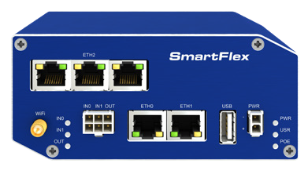

[***www.advantech-bb.com***](http://www.advantech-bb.com/)**/ *Enabling an Intelligent Planet*** All product specifications are subject to change without notice.

SmartFlex_SR300 March 5, 2024 10:57 AM

|  |  |  |
| --- | --- | --- |
| **POE PARAMETERS** | **POE PD**  **parameters for opposite PSE** | **P0E PSE** |
| Input voltage range | 42.5 – 57 V | 44 – 57 V, 65 W |
| Power available | 25.50 W | 2x 25.50 W (ETH0, ETH1) |
| Maximum current | 600 mA |  |
| Insul. Strength | 1.5 kV from the router | none |
| Standards IEEE 802.3at-2009 (PoE+) and IEEE 802.3af-2003 (PoE) supported. Cabling needed is Category 5, up to 12.5 Ω. It is possible to use a passive PoE injector | | |

|  |  |
| --- | --- |
| **MECHANICAL** | |
| Plastic or metal case with plastic or metal DIN rail | |
| Enclosure Dimensions | 55x97x125 mm |
| Weight Plastic | 170 g |
| Weight Metal | 375 g |

**HW SPECIFICATIONS**

|  |  |
| --- | --- |
| **PORTS, LED, ANTENNAS** | |
| 5x ETH ports | RJ45, 10/100 Mbps |
| LED Indicators | PWR, ETH, USR, POE, IN0, IN1, OUT |
| Wi-Fi Antenna (sold separately) | R-SMA connector |
| USB | USB Host connector 2.0 |
| SD Card | 1x Micro SD Card slot (rear panel) |
| RST | RESET button (rear panel) |

|  |  |
| --- | --- |
| **WI-FI - 802.11 A/B/G/N, AP OR CLIENT MODES *Optional** | |
| Supported Wi-Fi band | 2.4 GHz, 5.4 GHz |
| Encryption | None, WEP, TKIP, AES |
| 5 GHz supported channels | 36, 40, 44, 48, 52, 56, 60, 64, 149, 153, 157, 161, 165 |
| 2.4 GHz supported channels | 1, 2, 3, 4, 5, 6, 7, 8, 9, 10, 11, 12, 13, 14 |
| Number of clients | 10 |
| Authentication | Open, Shared, WPA–PSK, WPA2–PSK |

|  |  |
| --- | --- |
| **POWER** | |
| Power Supply (sold separately) | 10 – 60 VDC (2–Way Molex connector |
| Power Consumption | Idle: 2.5 W  Average: 4 W  Peak: 11 W  Sleep Mode: 10mW |
| **ENVIRONMENTAL** | |
| Temperature Range | Operating: -40 to +75 °C  Storage: -40 to +85 °C |
| Humidity | Operating: 0 to 95 %  Storage (Non-condensing): 0 to 95 % |
| Cold Start | -35 °C |
| Operating Altitude | 2000 m / 70 kPa |
| Ingress Protection Rating | IP30 |

|  |  |
| --- | --- |
| **SOFTWARE** | |
| Network and Routing | DHCP Server, , DHCP Client, NAT/PAT, VRRP, Dynamic DNS client, DNS proxy, VLAN, QoS, NTP Client/ Server, IGMP, BGP, OSPF, RIP, SMTP, SMTPS, SNMP v1/ v2c/ v3, Backup routes, PPP, PPPoE, SSL, Port Forwarding, Host Port Routing, Ethernet Bridging |
| Security | HTTPS, SSH, VPN tunnels, SFTP, Firewall (IP Filtering, MAC address filtering, Inbound and outbound Port filtering), DMZ (via iptables) |
| VPN Tunnelling | Open VPN client and server and P2P, L2TP, PPTP, GRE, EasyVPN, DMVPN, IPSec with IKEv1 and IKEv2 |
| Configuration | Web server, SSH, Four configuration switchable profiles, Automatic configuration update from server Backup configuration, Restore configuration |
| Firmware Management | Automatic firmware update from server, Locally via LAN and USB, Over-the-Air software updates |
| Diagnostic | One CLICK report – current configuration / factory identification / system log / kernel log / reboot log / routing table, Remote diagnostics possible via SSH |
| Status | Network Status, DHCP Status, IPSec Status, Statistics history for last 60 days |
| Log | System Log, Reboot Log, Kernel Log |
| Controlling and Diagnostic | SNMP v1/v2c/v3, Statuses, Log |
| Event Engine | StartUp script & Up/Down script (Bash), Digital Input, Network Parameters, Data Usage, Timer, Power, Device Temperature Report Types: email, SNMP Trap |
| Other | IPv6 support |

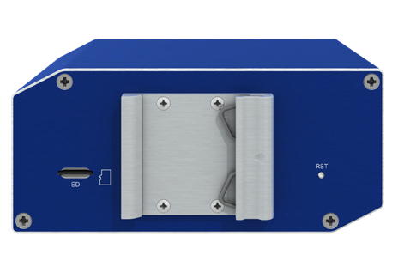

Robust metal or plastic case

**STANDARDS AND REGULATIONS ACCESSORIES**

|  |  |
| --- | --- |
| **ORDER CODE** | **DESCRIPTION** |
| BB-AW-A2458G-FSRPK | Antenna Wi-Fi, 2.4 & 5.8 GHz |
| BB-RPS-v3-MO2-M | SmartFlex Power Supply, 12V/1A |
| BB-RPS-v3-PSE | SmartFlex Power Supply, 48V/1.35A (power cord required) |
| BB-PWRCORD-US | USA - Power Supply Power Cord |
| BB-PWRCORD-EU | EU - Power Supply Power Cord |
| BB-PWRCORD-UK | UK - Power Supply Power Cord |
| BB-PWRCORD-AUS | AU - Power Supply Power Cord |
| BB-SBD40 | DIN Rail Clip - metal |
| BB-KN-v3-MO2-3 | PS Cable 2-wire, MO 2 pins, 3m, v3 routers |
| BB-KIO-v3-MO6-3 | IO Cable 6-wire, 3m, v3 routers |

|  |  |
| --- | --- |
| **INDUSTRY CERTIFICATIONS & APPROVALS** | |
|  | **SR300 - EMEA** |
| Radio | ETSI EN 300 328, ETSI EN 301 893 |
| EMC | ETSI EN 301 489-1, ETSI EN 301 489-1, ETSI EN 301 489-17 |
| Safety | IEC 62368-1 (UL E487720), EN 62311 UL C1D2  UL E486108 * |
| National | CE, UKCA compliant |

* Excluding versions with PoE PSE.

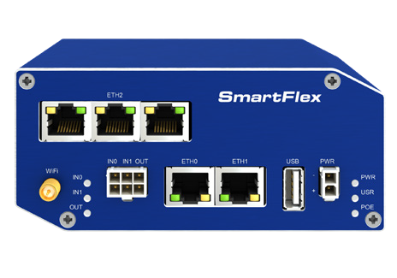

WiFi antenna connector

Power connector

USB Host

Ethernet 10/100 ports

PoE PSD capability

IN0, IN1, OUT

3-port SWITCH

|  |  |
| --- | --- |
|  |  |
| SD card sl | ot |

|  |  |
| --- | --- |
|  |  |
| DIN ho | lder |

|  |  |
| --- | --- |
|  |  |
| RESET bu | tton |